Hello! If you are self-isolating, we can help.

If you need help with

Picking up shopping,
Posting mail
A friendly phone call
Urgent supplies

please send us an email at
Or give us a call on 01604 785836

Or if you are willing to help us with those things
Or if you just wish to receive Abington Pastoral Letters

Then please send us an email at bob.purser@abingtonchurch.org.uk
Or give us a call on 01604 785836

If you need an urgent pastoral support from the parish priest, please contact the Rector, Revd. Jun Kim at rector@abingtonchurch.org.uk or Lay Pastoral Minister, Liz Kelly on 01604 636947

Your Parish Church is here for you. May God bless you and your family in these challenging times.

Prayers and Warmest Wishes from
The Parish Church of
St Peter and St. Paul, Abington

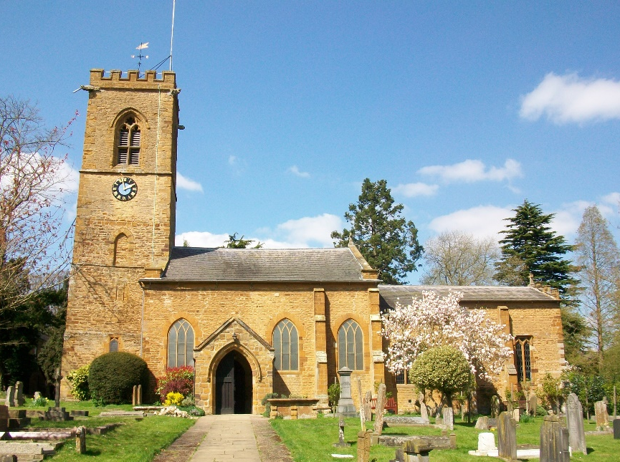

‘The Church In The Park’

www.abingtonchurch.org.uk
Facebook: @abingtonchurchinthepark

