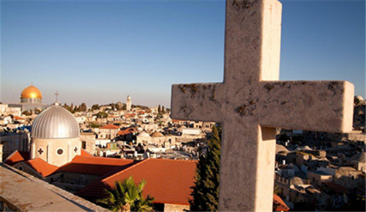
Holy Land Pilgrimage: Reflections and Thanksgivings

As many of you may know, I was very privileged to go on a 10 day pilgrimage to the Holy Land in January this year. By then the coronavirus infection was beginning to cause problems in China. However little did we think then that, within a few months, we would be in the middle of a significant pandemic, affecting people throughout the world.
During the current ‘lockdown’, I have had more time to reflect on this pilgrimage and on what I have learned from the experience.
Firstly a pilgrimage is about a journey and not a destination. I was invited with my brother, Richard, to join him and his wife, Sarah, on the pilgrimage, which was being organised by two priests from the Diocese of Coventry. I was part of a group of 45, most of whom didn’t know each other, but over the course of the pilgrimage, strong friendships were formed and we all shared and experienced so much. We were all ‘journeying’ together.
I don’t think it is possible to visit the Holy Land and not be very moved by being in places where Jesus lived and ministered. The bible stories that we read and study take on new meanings when one can visualise where these events may have taken place. Even though Jesus lived 2000 years ago, the Sea of Galilee and the surrounding area is, I believe, not so different to how it was in Jesus’ time.
We are called to follow Christ, not merely to observe him. The Christian life is often referred to as a ‘walk’, in other words it is active and not passive. Walking implies movement forward and moving forward implies change. We did lots of walking during the ten days away! At the beginning of the pilgrimage, on the shore of the Sea of Galilee, we heard again Christ’s call to those early disciples ‘Come, follow me’ and through the places we visited, we were reminded again of how their lives were totally transformed. Our Christian life is to be lived in response to the same instruction, we are to undergo similar transformation.
During the coronavirus crisis we are living with many restrictions, and people are understandably isolated and fearful. I am reminded of the Palestinian Christians that we met, whose daily reality is a lockdown situation, where essential supplies are often in short supply, where there is no freedom of movement and where they may only have electricity for four hours a day. Our situation is still far from what many people around the world experience every day of their lives. Yet despite these restrictions, we were welcomed with generous acts of love and hospitality.
My prayer at this time is that, acknowledging the very real hardships, pain and grief caused as a result of the pandemic, we use this time to thank God for our blessings, remembering those who live with daily injustices, persecution and inequality.

Cathy Tinsley 20th April 2020

