THE GARDEN OF YOUR LIFE
Go into your garden if you have one or take a walk around your neighbourhood. You might want to take paper and something to write or draw with. As you walk, look at the garden, or the gardens you can see out and about, and, as you do so, take an imaginary walk around the garden of your life.
First, form a general impression of it. How would you describe it: a formal garden, a cottage-type garden, a vegetable garden, a patio, a rockery, a wild flower meadow, a tangle of weeds, an orchard, or ……………. ?
Draw a picture if this helps you.
Then look closer to see what is growing there. Identify the activities and responsibilities that are, or were, yours.
What is:
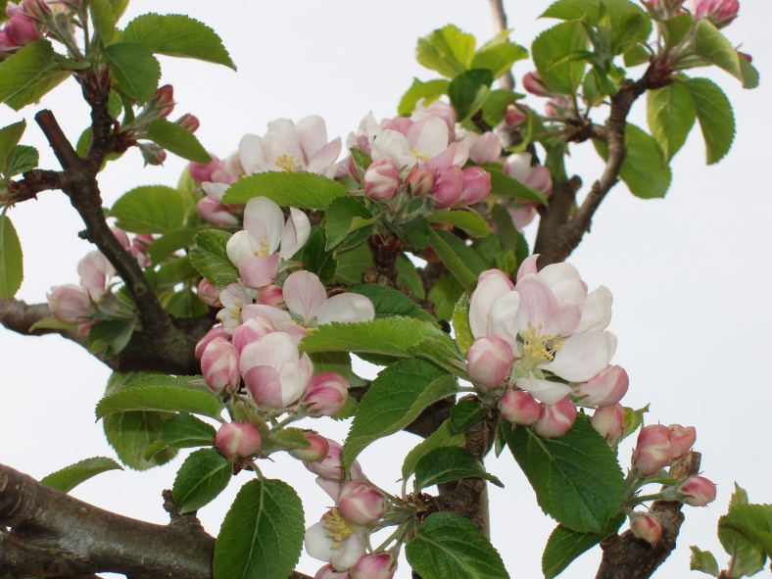
- in bud?
- opening?
- in full bloom?
- fruit-bearing?
- smothered by other growth?
- dormant?
- dying or dead?

Is there anything that needs:
- pruning?
- weeding out?
- freeing or feeding?
- changing?
- harvesting?

Imagine Jesus comes into your garden. See his enjoyment at being there. What might he say about it? Will that mean any changes for you?
Listen to him telling you that his desire is to work with you in tending your garden.
Material by Ann Persson, slightly adapted, from ‘Quiet Spaces’ Sept-Dec 2015, a BRF publication.

